**DAY12 ASSIGNMENT**

**NAME: SUDHA SREELATHA**

**EMP ID: 46255249**

**Created INTERFACE IN SFP:**

**Dynamic text field importing:**

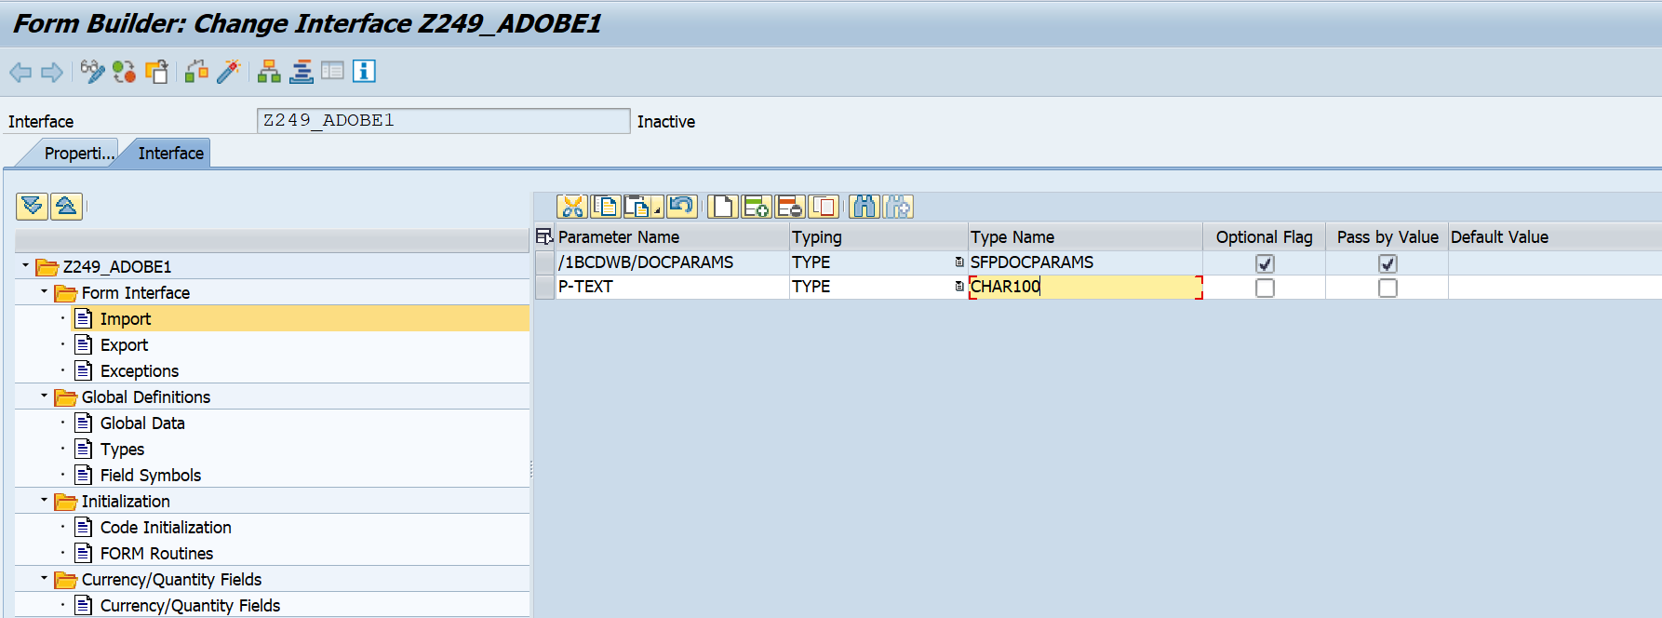

**se78- uploading image:**

**Global data in interface:**

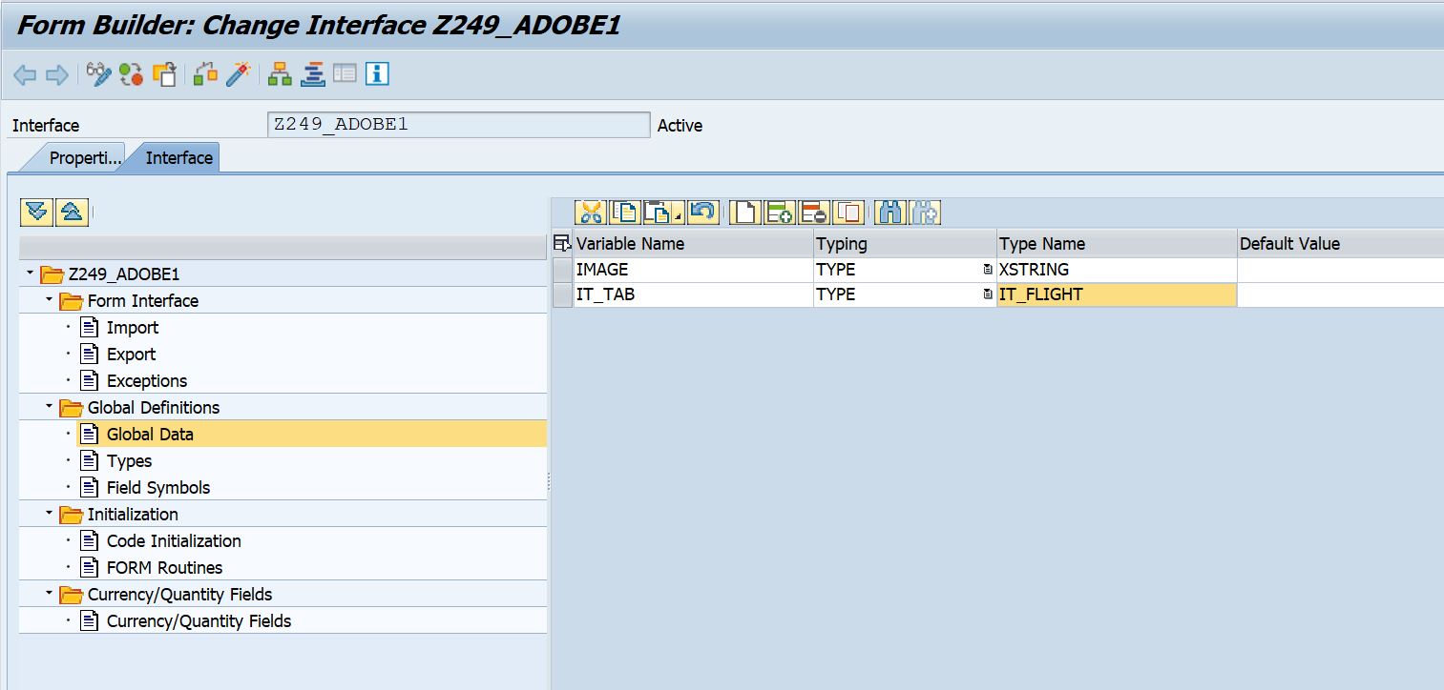

**Structure and table type:**

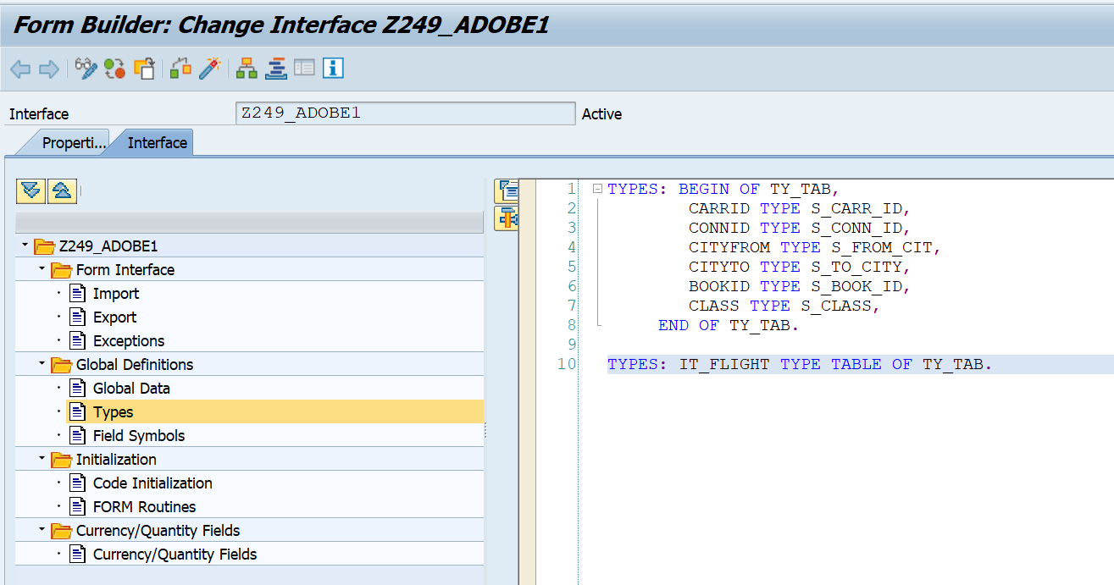

**Code initialization:**

CALL METHOD CL_SSF_XSF_UTILITIES=>GET_BDS_GRAPHIC_AS_BMP  
  EXPORTING  
    P_OBJECT       = 'GRAPHICS'  
    P_NAME         = 'CG'  
    P_ID           = 'BMAP'  
    P_BTYPE        = 'BCOL'  
  RECEIVING  
    P_BMP          = IMAGE  
  EXCEPTIONS  
    NOT_FOUND      = 1  
    INTERNAL_ERROR = 2  
    OTHERS         = 3  
        .  
IF SY-SUBRC <> 0.  
* Implement suitable error handling here  
ENDIF.  
  
  
  SELECT  
  
  A~CARRID  A~CONNID B~CITYFROM B~CITYTO C~BOOKID C~CLASS  
  FROM SFLIGHT AS A INNER JOIN SPFLI AS B ON A~CARRID EQ B~CARRID  
  INNER JOIN SBOOK AS C ON B~CARRID EQ C~CARRID INTO TABLE IT_TAB UP TO 50 ROWS.

**FORM:**

**LAYOUT:**

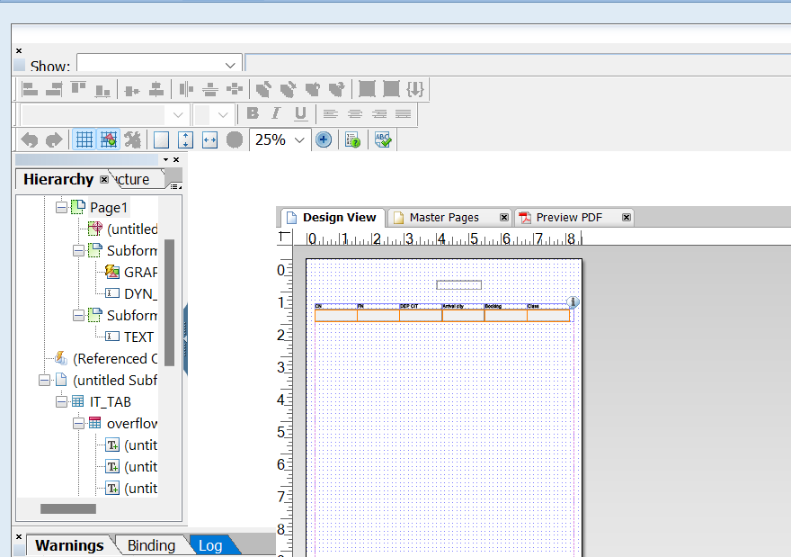

**OUTPUT:**

